DAX Formulas
This document compiles all the DAX formulas used to build and customize the Power BI dashboard for the Demand Forecasting project. It serves as a quick reference for how key metrics and calculations were created to analyze sales trends, compare model forecasts, and visualize.

Average XGB Forecast
Average Forecast (Ensemble)
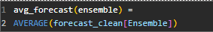
Average LGBM Forecast
Average Random Forest Forecast
No. Of Items
No. Of Stores
Total Forecast (Ensemble)
